Day 374 — Searching & Sorting Revision
Task: Revise linear search, binary search, bubble sort, selection sort, insertion sort, merge sort, quick sort, and heap sort. Memorize their best, average, and worst-case time complexities and auxiliary space complexities.
The most important thing to remember is that searching finds an element, while sorting arranges elements in a particular order. Your choice of algorithm depends on whether the data is sorted, the input size, memory constraints, and stability requirements.
1. Searching algorithms
A. Linear Search
Linear search checks elements one by one until the target is found or the collection ends.
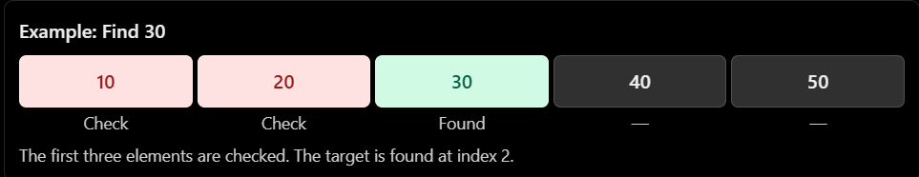

C++ implementation
#include <iostream>
#include <vector>
using namespace std;

int linearSearch(const vector<int>& arr, int target) {
for (int i = 0; i < static_cast<int>(arr.size()); i++) {
if (arr[i] == target)
return i;
}
return -1;
}

int main() {
vector<int> arr = {10, 20, 30, 40, 50};
cout << linearSearch(arr, 30); // 2
}
Complexity
Case | Time
Best | \(O(1)\)
Average | \(O(n)\)
Worst | \(O(n)\)
Auxiliary space | \(O(1)\)
Use linear search when:
- The collection is unsorted.
- The input is small.
- You only need to search once.
- The data structure doesn't support efficient random access.
B. Binary Search
Binary search repeatedly halves the search interval. It requires the input to be sorted and works most naturally on a random-access sequence such as a vector.
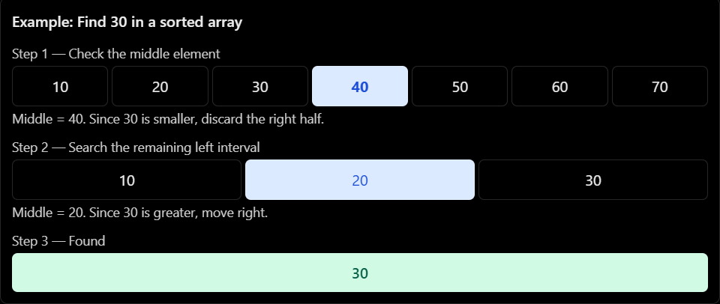

C++ implementation
#include <iostream>
#include <vector>
using namespace std;

int binarySearch(const vector<int>& arr, int target) {
int left = 0;
int right = static_cast<int>(arr.size()) - 1;

while (left <= right) {
int mid = left + (right - left) / 2;

if (arr[mid] == target) {
return mid;
}

if (arr[mid] < target) {
left = mid + 1;
} else {
right = mid - 1;
}
}
return -1;
}

int main() {
vector<int> arr = {10, 20, 30, 40, 50};
cout << binarySearch(arr, 40); // 3
}
Use left + (right - left) / 2 to avoid the potential overflow associated with (left + right) / 2 for large indices.
Complexity
Case | Time
Best | \(O(1)\)
Average | \(O(\log n)\)
Worst | \(O(\log n)\)
Auxiliary space, iterative | \(O(1)\)
Auxiliary space, recursive | \(O(\log n)\)
Use binary search when:
- The data is sorted.
- Random access is efficient.
- You need to find a value or a boundary such as the first element greater than or equal to a target.
2. Sorting algorithms
A. Bubble Sort
Bubble sort repeatedly compares adjacent elements and swaps them if they are in the wrong order. After each pass, a large element moves toward the end.
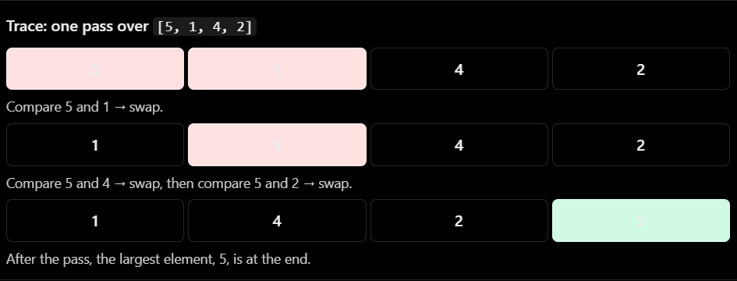

C++ implementation
void bubbleSort(vector<int>& arr) {
int n = static_cast<int>(arr.size());

for (int i = 0; i < n - 1; i++) {
bool swapped = false;

for (int j = 0; j < n - 1 - i; j++) {
if (arr[j] > arr[j + 1]) {
swap(arr[j], arr[j + 1]);
swapped = true;
}
}

if (!swapped) {
break;
}
}
}
Required headers for this snippet: <vector> and <algorithm> or an appropriate declaration for swap.
Case | Time
Best, with early exit | \(O(n)\)
Average | \(O(n^2)\)
Worst | \(O(n^2)\)
Auxiliary space | \(O(1)\)
Properties: Stable, in-place.
Use: Learning sorting fundamentals, tiny datasets, or nearly sorted input when using the early-exit optimization. It is rarely the best choice for large datasets.

B. Selection Sort
Selection sort repeatedly finds the smallest element in the unsorted portion and places it at the beginning of that portion.
Example:
[64, 25, 12, 22, 11]
- Pass 1: find 11, swap it with 64.
- Pass 2: find 12 in the remaining portion.
- Pass 3: find 22.
- Continue until sorted.

C++ implementation
void selectionSort(vector<int>& arr) {
int n = static_cast<int>(arr.size());

for (int i = 0; i < n - 1; i++) {
int minIndex = i;

for (int j = i + 1; j < n; j++) {
if (arr[j] < arr[minIndex]) {
minIndex = j;
}
}

if (minIndex != i) {
swap(arr[i], arr[minIndex]);
}
}
}

Case | Time
Best | \(O(n^2)\)
Average | \(O(n^2)\)
Worst | \(O(n^2)\)
Auxiliary space | \(O(1)\)
Properties: In-place, generally unstable.
Use: Small datasets or situations where minimizing the number of swaps matters. Even sorted input still requires scanning the remaining elements to find each minimum.

C. Insertion Sort
Insertion sort builds a sorted portion from left to right. Each new element is inserted into its correct position in the already sorted portion.
Example:
[5, 2, 4, 1]
- Start with [5].
- Insert 2 → [2, 5].
- Insert 4 → [2, 4, 5].
- Insert 1 → [1, 2, 4, 5].
C++ implementation
void insertionSort(vector<int>& arr) {
int n = static_cast<int>(arr.size());

for (int i = 1; i < n; i++) {
int key = arr[i];
int j = i - 1;

while (j >= 0 && arr[j] > key) {
arr[j + 1] = arr[j];
j--;
}
arr[j + 1] = key;
}
}
Case | Time
Best, already sorted | \(O(n)\)
Average | \(O(n^2)\)
Worst, reverse sorted | \(O(n^2)\)
Auxiliary space | \(O(1)\)
Properties: Stable, in-place.
Use: Small or nearly sorted arrays, and as a component inside more advanced sorting algorithms.
D. Merge Sort
Merge sort uses the divide-and-conquer technique:
- Divide the array into two halves.
- Recursively sort each half.
- Merge the two sorted halves.
Example:
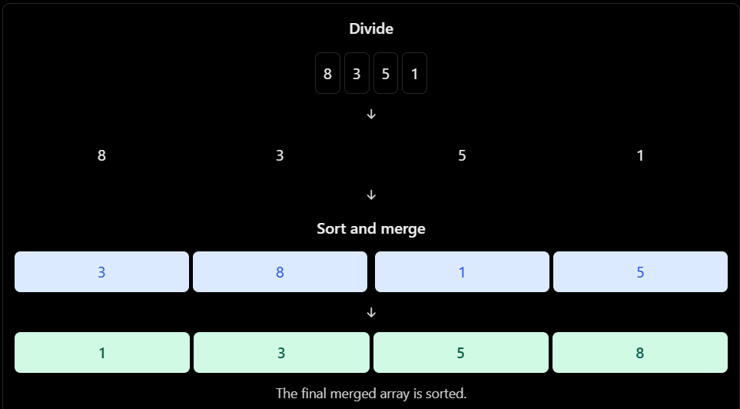

C++ implementation
#include <vector>
using namespace std;

void merge(vector<int>& arr, int left, int mid, int right) {
vector<int> temp;
int i = left;
int j = mid + 1;

while (i <= mid && j <= right) {
if (arr[i] <= arr[j]) {
temp.push_back(arr[i++]);
} else {
temp.push_back(arr[j++]);
}
}

while (i <= mid) {
temp.push_back(arr[i++]);
}

while (j <= right) {
temp.push_back(arr[j++]);
}

for (int k = 0; k < static_cast<int>(temp.size()); k++) {
arr[left + k] = temp[k];
}
}

void mergeSort(vector<int>& arr, int left, int right) {
if (left >= right) {
return;
}

int mid = left + (right - left) / 2;

mergeSort(arr, left, mid);
mergeSort(arr, mid + 1, right);

merge(arr, left, mid, right);
}

Call it using:
mergeSort(arr, 0, static_cast<int>(arr.size()) - 1);
For an empty vector, this call passes right = -1, which the base case handles correctly.
Complexity
Case | Time
Best | \(O(n\log n)\)
Average | \(O(n\log n)\)
Worst | \(O(n\log n)\)
Auxiliary space for this array implementation | \(O(n)\)
Properties: Stable, divide-and-conquer, not in-place in the usual array implementation.
Use:
- Large datasets where predictable \(O(n\log n)\) time is important.
- Stable sorting.
- Linked-list sorting.
- External sorting when data doesn't fit in memory.
- Counting inversions using a modified merge sort.
Memory trick: Merge sort divides, sorts, and merges. Its time complexity remains \(O(n\log n)\) in all three cases.
E. Quick Sort
Quick sort also uses divide-and-conquer, but partitions the array around a pivot.
- Select a pivot.
- Partition elements around the pivot.
- Recursively sort the two resulting regions.
The pivot's final position separates elements that belong on its left from elements that belong on its right. Depending on the partition scheme, values equal to the pivot may appear on either side.

C++ implementation
This version uses the last element as the pivot and Lomuto partitioning.
#include <vector>
#include <algorithm>
using namespace std;

int partitionArray(vector<int>& arr, int low, int high) {
int pivot = arr[high];
int i = low;

for (int j = low; j < high; j++) {
if (arr[j] <= pivot) {
swap(arr[i], arr[j]);
i++;
}
}
swap(arr[i], arr[high]);
return i;
}

void quickSort(vector<int>& arr, int low, int high) {
if (low >= high) {
return;
}
int pivotIndex = partitionArray(arr, low, high);

quickSort(arr, low, pivotIndex - 1);
quickSort(arr, pivotIndex + 1, high);
}
Call:
quickSort(arr, 0, static_cast<int>(arr.size()) - 1);
Complexity
Case | Time
Best | \(O(n\log n)\)
Average | \(O(n\log n)\)
Worst | \(O(n^2)\)
Auxiliary space, average recursion stack | \(O(\log n)\)
Auxiliary space, worst recursion stack | \(O(n)\)
Properties: Usually in-place with respect to the array, but not stable. The implementation above uses extra recursion-stack space.
Use:
- General-purpose sorting when average performance is good.
- In-memory arrays.
- Quickselect-style partitioning for selection problems.
Why can quick sort become \(O(n^2)\)?
If the pivot repeatedly divides the array into highly unbalanced partitions, such as sizes \(0\) and \(n-1\), each partition processes nearly all remaining elements.
Improvement: Randomized pivot selection or a carefully designed pivot strategy reduces the likelihood of poor partitions, although simple quick sort still has a quadratic worst case.
F. Heap Sort
Heap sort uses a binary heap to repeatedly extract the largest element and place it at the end of the unsorted region.
For ascending order, the standard approach uses a max-heap.
Process
- Build a max-heap.
- Swap the root (maximum) with the last element.
- Reduce the heap size.
- Restore the heap property.
- Repeat until sorted.

C++ implementation
#include <vector>
#include <algorithm>
using namespace std;

void heapify(vector<int>& arr, int n, int root) {
int largest = root;
int left = 2 * root + 1;
int right = 2 * root + 2;

if (left < n && arr[left] > arr[largest]) {
largest = left;
}

if (right < n && arr[right] > arr[largest]) {
largest = right;
}

if (largest != root) {
swap(arr[root], arr[largest]);
heapify(arr, n, largest);
}
}

void heapSort(vector<int>& arr) {
int n = static_cast<int>(arr.size());

// Build the max-heap.
for (int i = n / 2 - 1; i >= 0; i--) {
heapify(arr, n, i);
}

// Move the maximum to the end.
for (int i = n - 1; i > 0; i--) {
swap(arr[0], arr[i]);
heapify(arr, i, 0);
}
}
Complexity
Case | Time
Best | \(O(n\log n)\)
Average | \(O(n\log n)\)
Worst | \(O(n\log n)\)
Auxiliary space for this recursive implementation | \(O(\log n)\) worst-case recursion stack
The last space figure is important: this specific implementation uses recursive heapify(), so it is not strictly \(O(1)\) auxiliary space. An iterative heapify() implementation makes standard array heap sort \(O(1)\) auxiliary space.
Properties: In-place in the conventional iterative implementation, not stable, guaranteed \(O(n\log n)\) time.
Use:
- When worst-case \(O(n\log n)\) time is important.
- When a predictable upper bound matters.
- When constant auxiliary space is desired with an iterative implementation.
3. Master complexity table — memorize this
This is the most important revision table for exams and interviews. Space complexity below means auxiliary space, excluding the input array, unless otherwise stated.
Searching
Algorithm | Best time | Average time | Worst time | Auxiliary space
Linear search | \(O(1)\) | \(O(n)\) | \(O(n)\) | \(O(1)\)
Binary search, iterative | \(O(1)\) | \(O(\log n)\) | \(O(\log n)\) | \(O(1)\)
Sorting
Algorithm | Best time | Average time | Worst time | Auxiliary space
Bubble sort, optimized | \(O(n)\) | \(O(n^2)\) | \(O(n^2)\) | \(O(1)\)
Selection sort | \(O(n^2)\) | \(O(n^2)\) | \(O(n^2)\) | \(O(1)\)
Insertion sort | \(O(n)\) | \(O(n^2)\) | \(O(n^2)\) | \(O(1)\)
Merge sort, array | \(O(n\log n)\) | \(O(n\log n)\) | \(O(n\log n)\) | \(O(n)\)
Quick sort, standard implementation | \(O(n\log n)\) | \(O(n\log n)\) | \(O(n^2)\) | Average \(O(\log n)\); worst \(O(n)\)
Heap sort, iterative heapify | \(O(n\log n)\) | \(O(n\log n)\) | \(O(n\log n)\) | \(O(1)\)
Important qualifications:
- Bubble sort's \(O(n)\) best case requires the early-exit optimization.
- Binary search's complexity assumes sorted, random-access data.
- Quick sort's average-case figures assume reasonably balanced partitions.
- Heap construction takes \(O(n)\), not \(O(n\log n)\); the repeated extraction phase takes \(O(n\log n)\).
- The recursive heap sort implementation above uses \(O(\log n)\) stack space, while the iterative version achieves \(O(1)\) auxiliary space.
4. Stability and in-place sorting
Two properties are often asked separately from time complexity.
Stable sorting: Equal-key elements preserve their relative order from the input.
In-place sorting: Uses little additional storage, usually \(O(1)\) auxiliary space in the conventional definition.
Algorithm | Stable? | In-place?
Bubble sort | Yes | Yes
Selection sort | Usually no | Yes
Insertion sort | Yes | Yes
Merge sort | Yes, with a stable merge | Usually no for arrays
Quick sort | Usually no | Usually yes for the array, excluding recursion stack
Heap sort | No | Yes with iterative heapify
Example of stability
Suppose students are sorted by marks:
[(Aman, 90), (Riya, 80), (Harshit, 90)]
A stable ascending sort places Riya first, then preserves Aman's position before Harshit among the two students with equal marks.
Stability matters when sorting records by multiple keys in successive operations.
5. How to choose an algorithm in practice
Search an unsorted array
Use linear search: \(O(n)\).
Search a sorted array
Use binary search: \(O(\log n)\).
Learn basic sorting or handle a tiny, nearly sorted array
Bubble sort, selection sort or insertion sort. Insertion sort is often especially effective on nearly sorted data.
Need stability and guaranteed \(O(n\log n)\) time
Merge sort is a strong choice.
Need good average in-memory sorting performance
Quick sort is a useful algorithm to understand, but production implementations commonly use more robust variants.
Need guaranteed \(O(n\log n)\) sorting and constant extra space
Use heap sort with iterative heap operations.
In everyday C++, use std::sort() for general-purpose sorting and std::stable_sort() when stability is required. Standard-library implementations commonly use hybrid algorithms rather than the simple implementations above.

